Main Profile Sharing Section- “Check out my wish list on ChipedIn! Chipedin.com/Amine123”
(Share the profile picture)
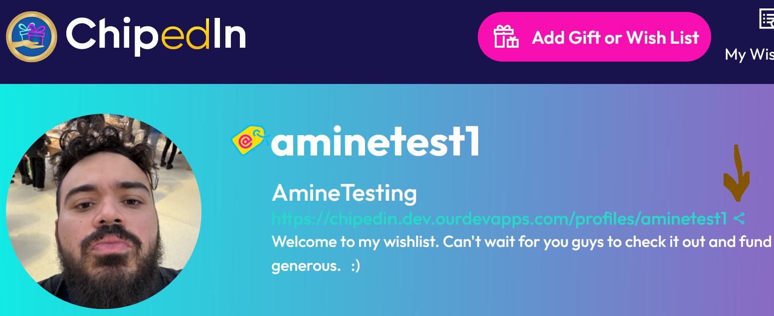
- Facebook
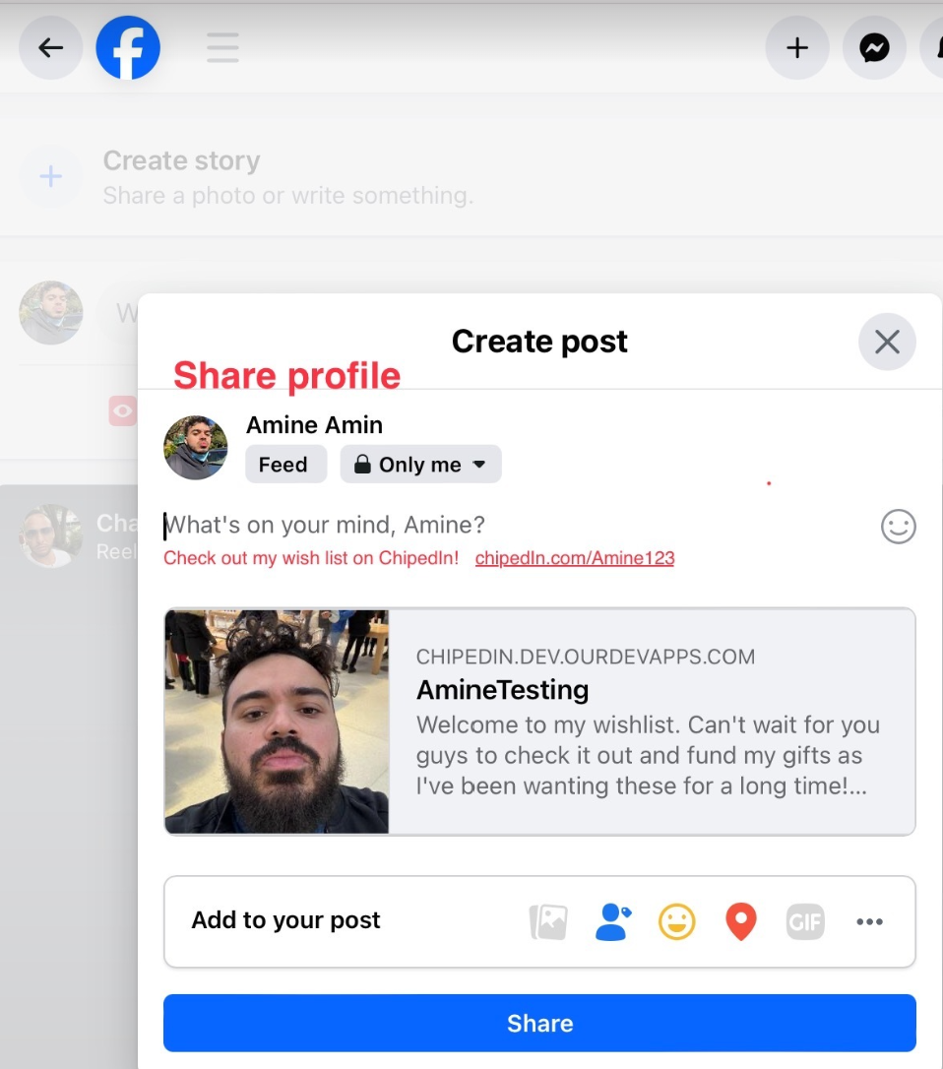
- X
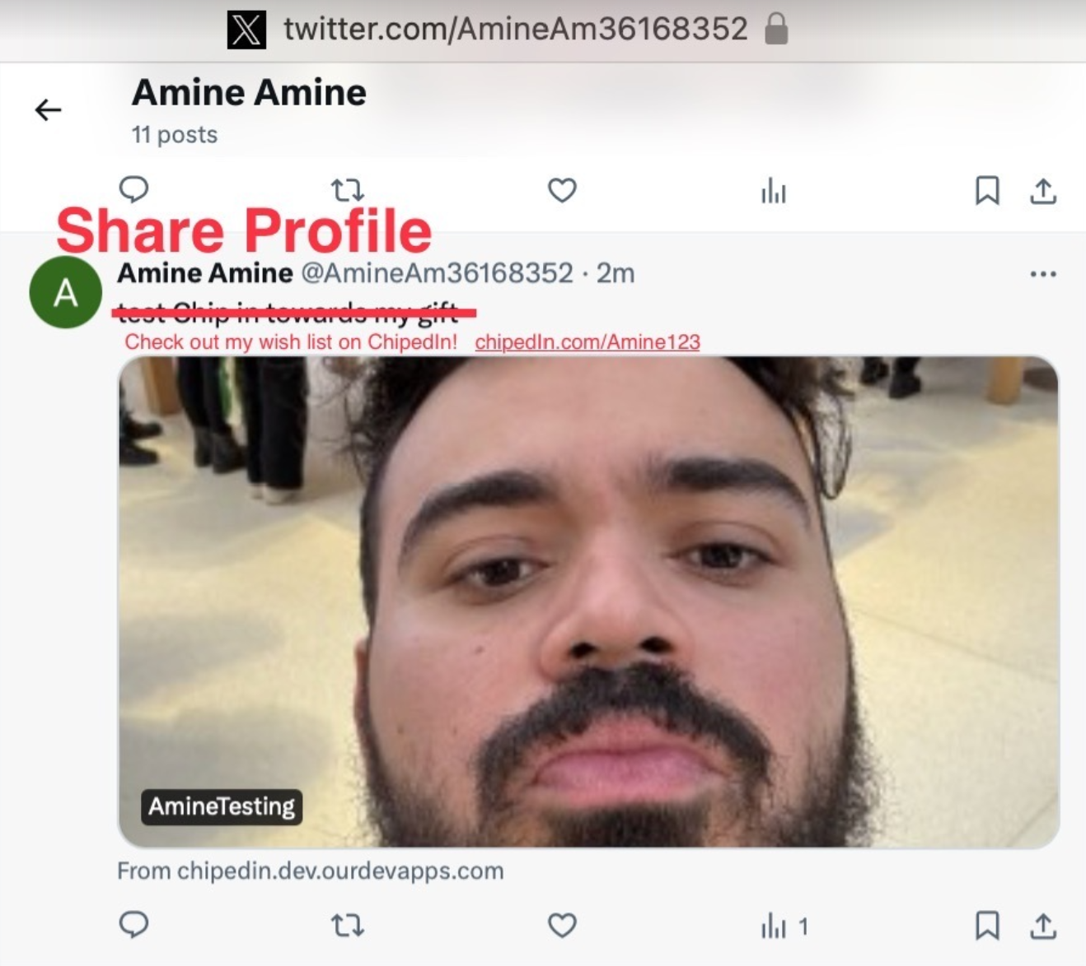
Welcome Video sharing section “Check out my wish list on ChipedIn! Chipedin.com/Amine123” (Share the video or picture greeting)
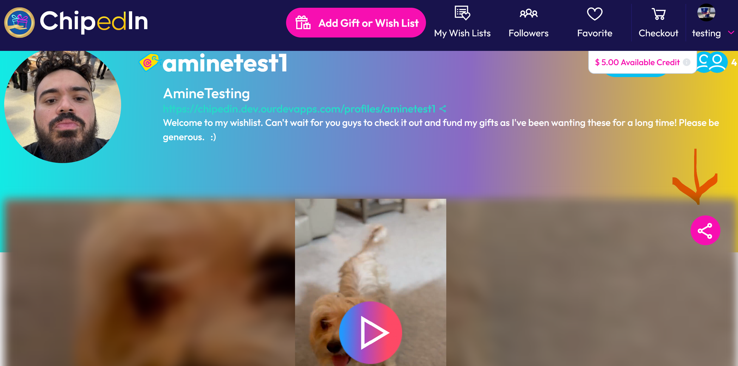
- Facebook
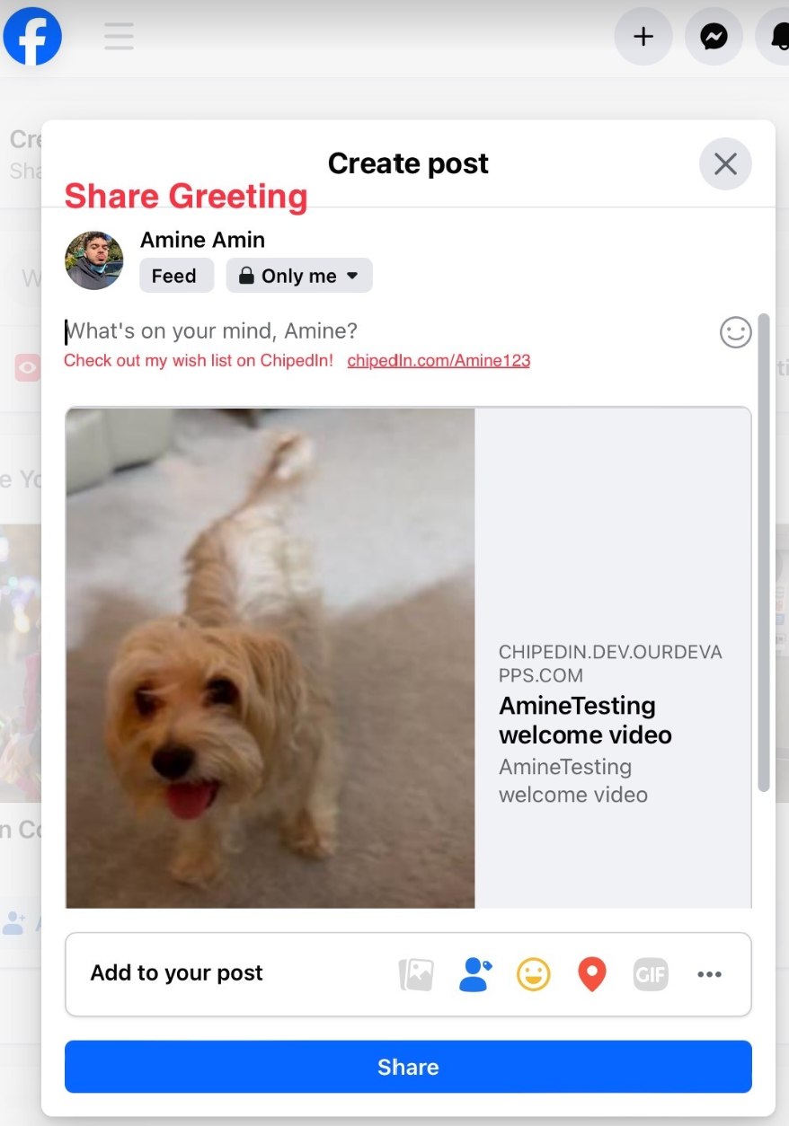
- X
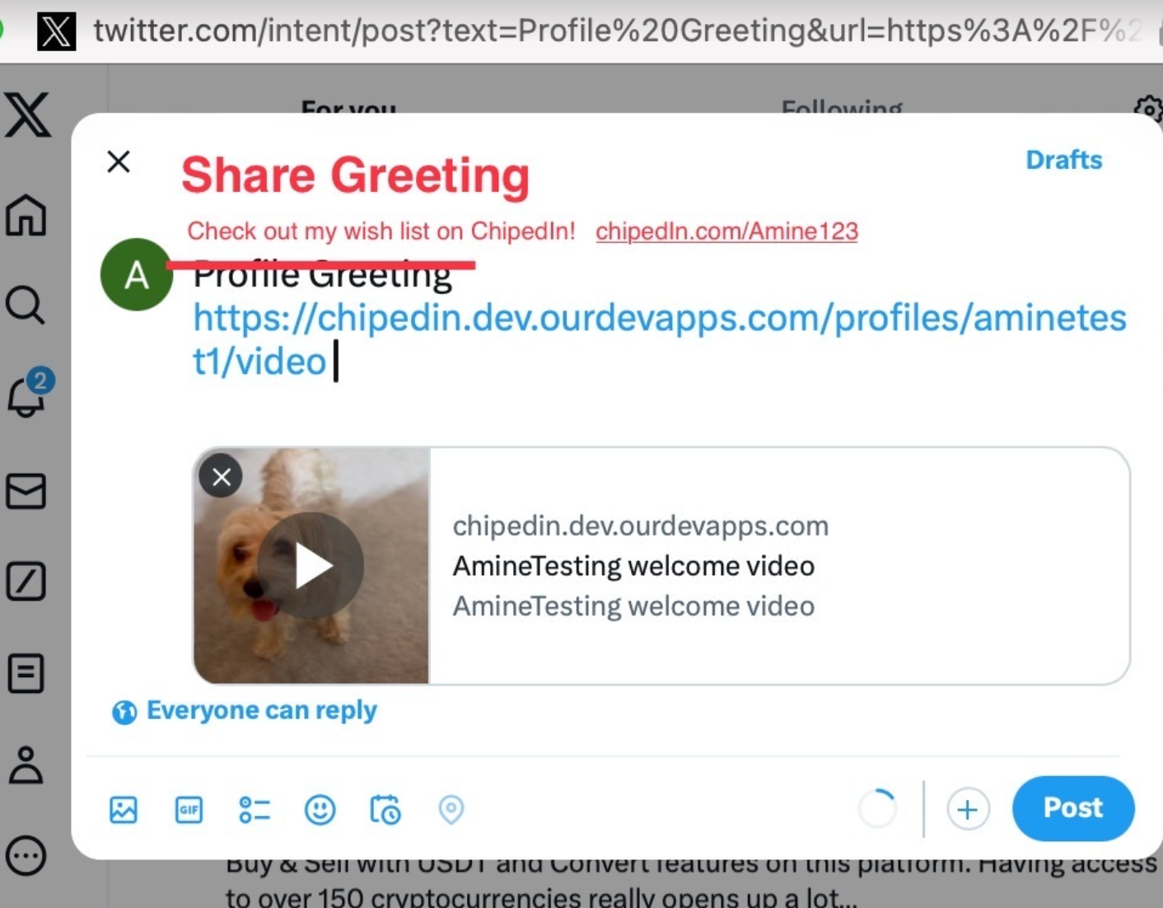
- Email – Change subject line to “Check out my wish list on ChipedIn!”
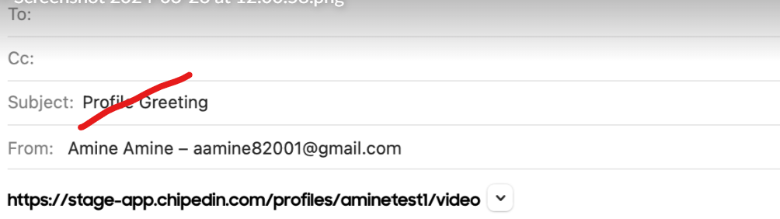

Sharing individual items on wish list “Check out my gift on ChipedIn! Chipedin.com/Amine123/Gift” (Share the item picture)
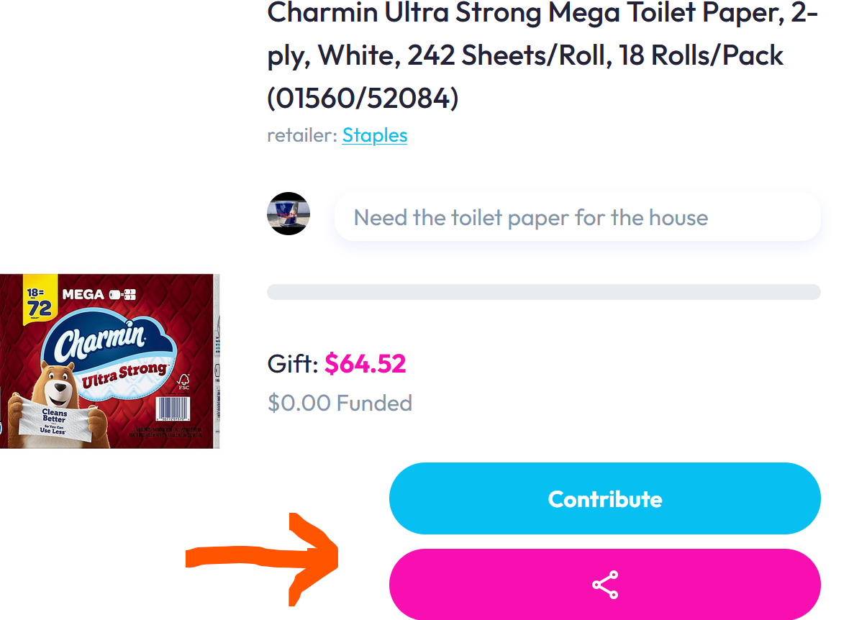

- Facebook / X:
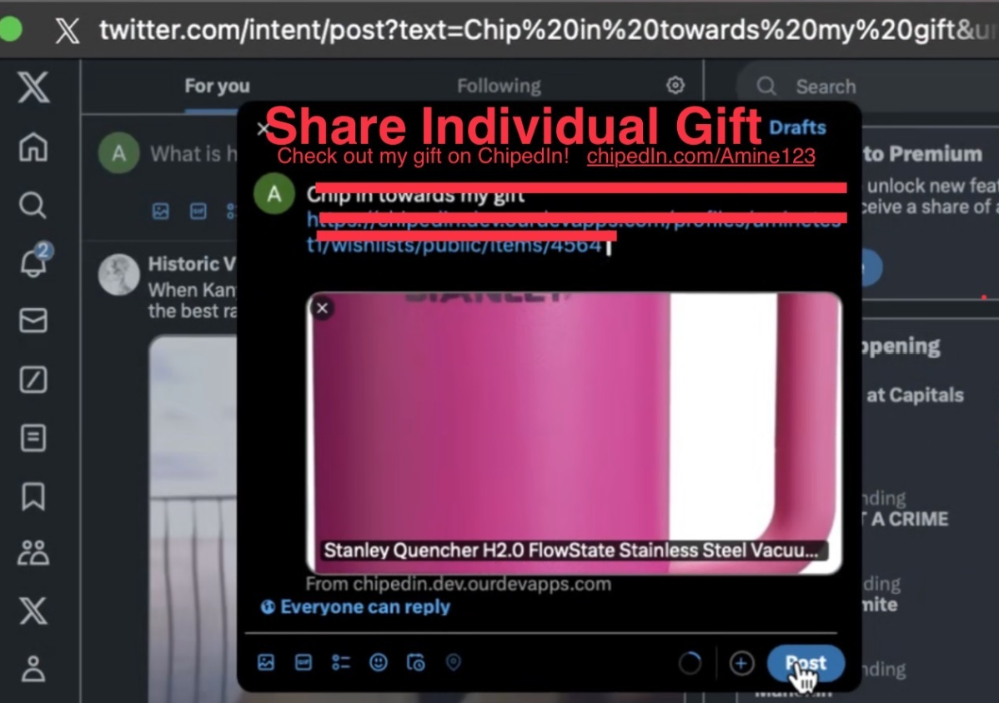
- Email – Change subject line to “Check out my gift on ChipedIn!”
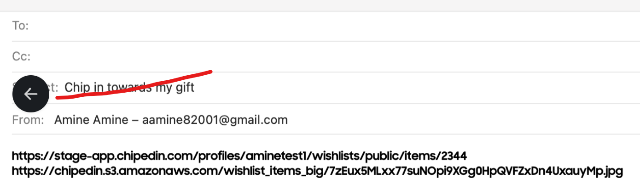

Sharing Shared Wish List or Gift - “Check out my wish list on ChipedIn! Chipedin.com/Amine123” (wish list) or “Check out my gift on ChipedIn! Chipedin.com/Amine123/Gift” (gift)
(Share the wish list OR individual item picture)
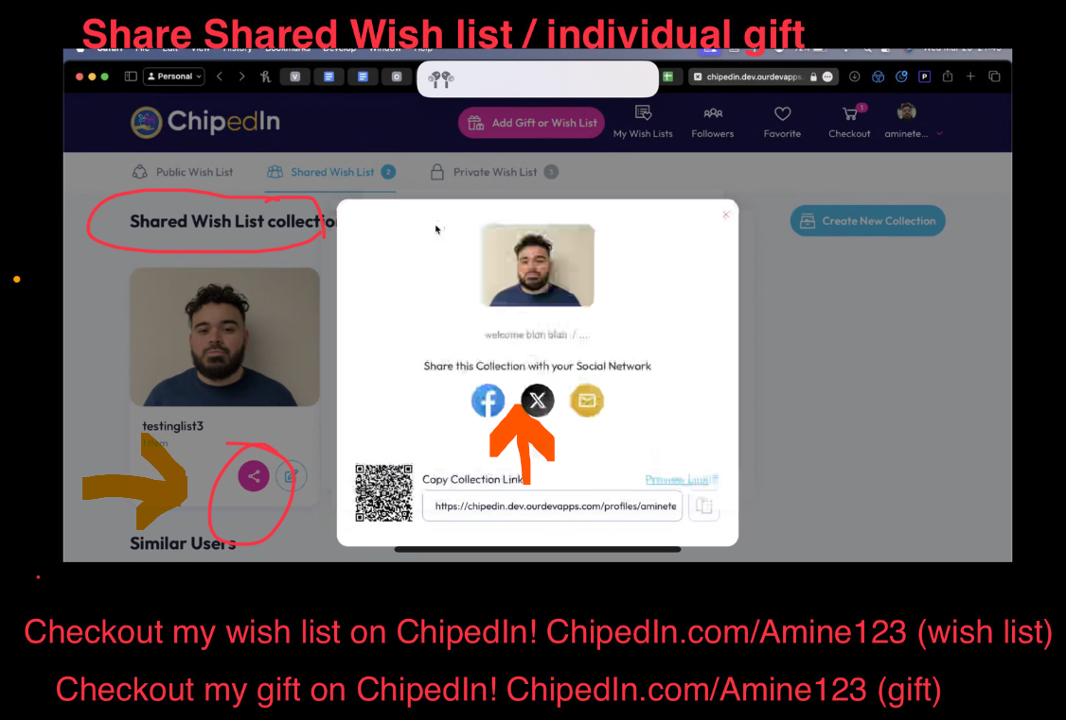

Send a Thank You Sharing Section“Thank you for chipping in towards my gift! Chipedin.com/Amine123”
(Share the Thank you Video or Picture)
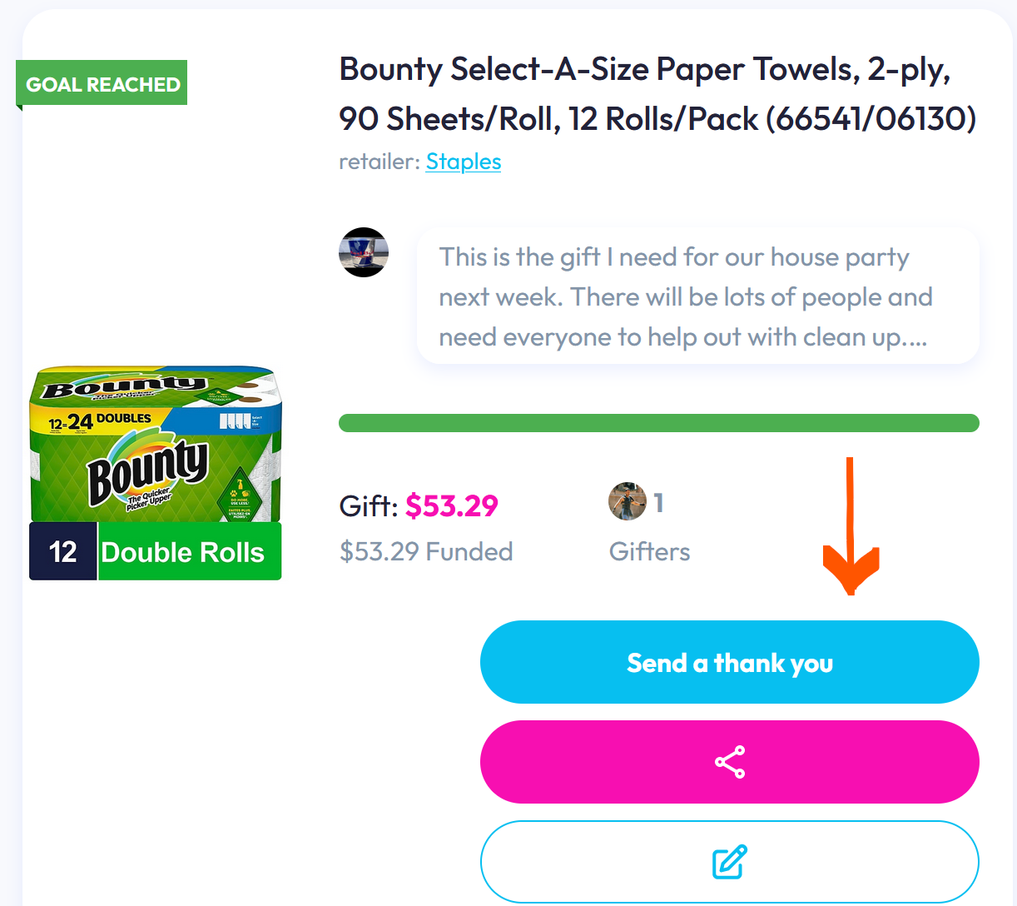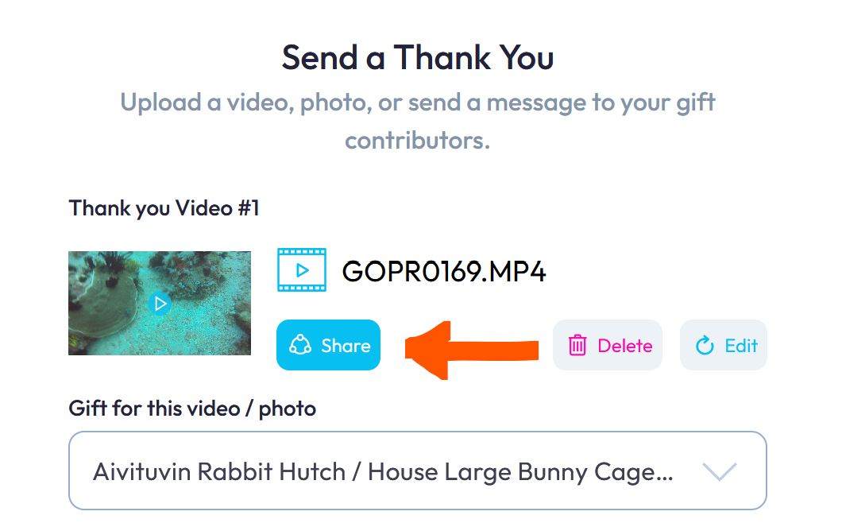
- Facebook
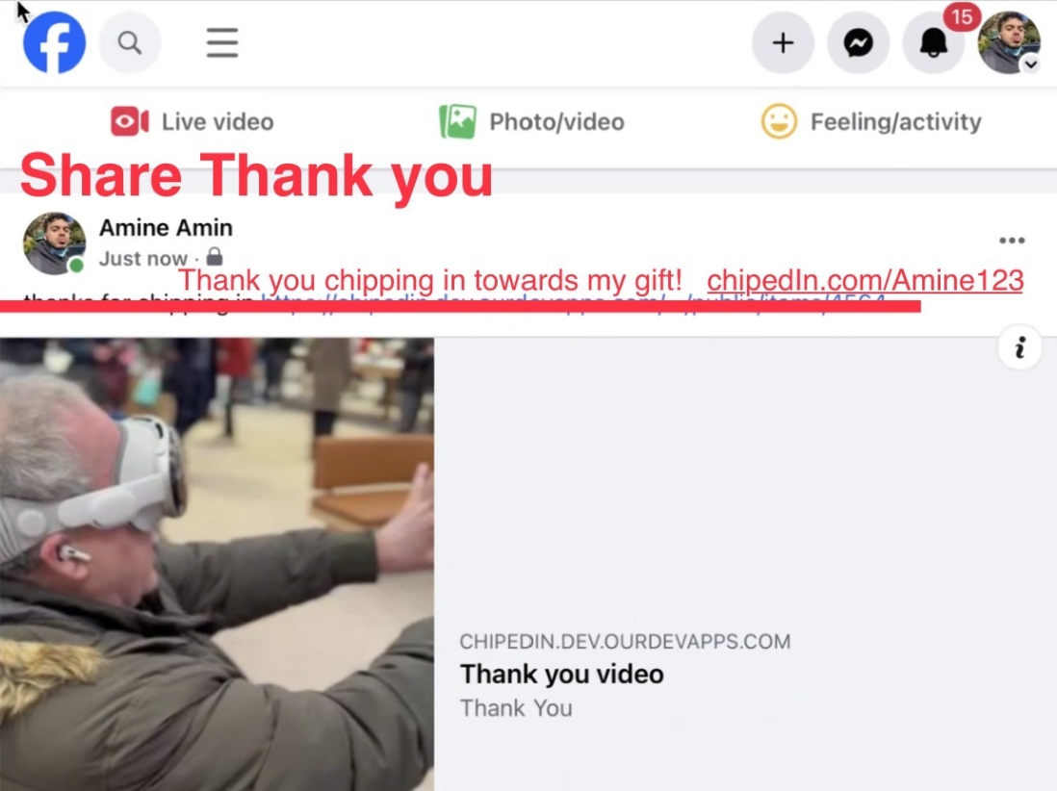
X:
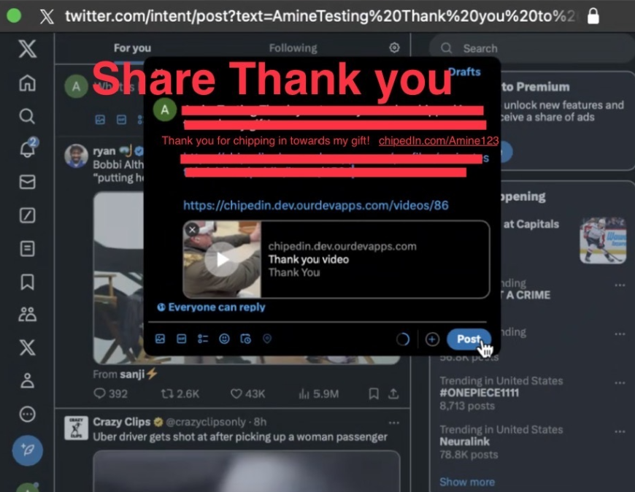

GOAL REACHED Sharing Section“Thank you for chipping in towards my gift! Chipedin.com/Amine123/Gift”
(Share the Individual Picture)
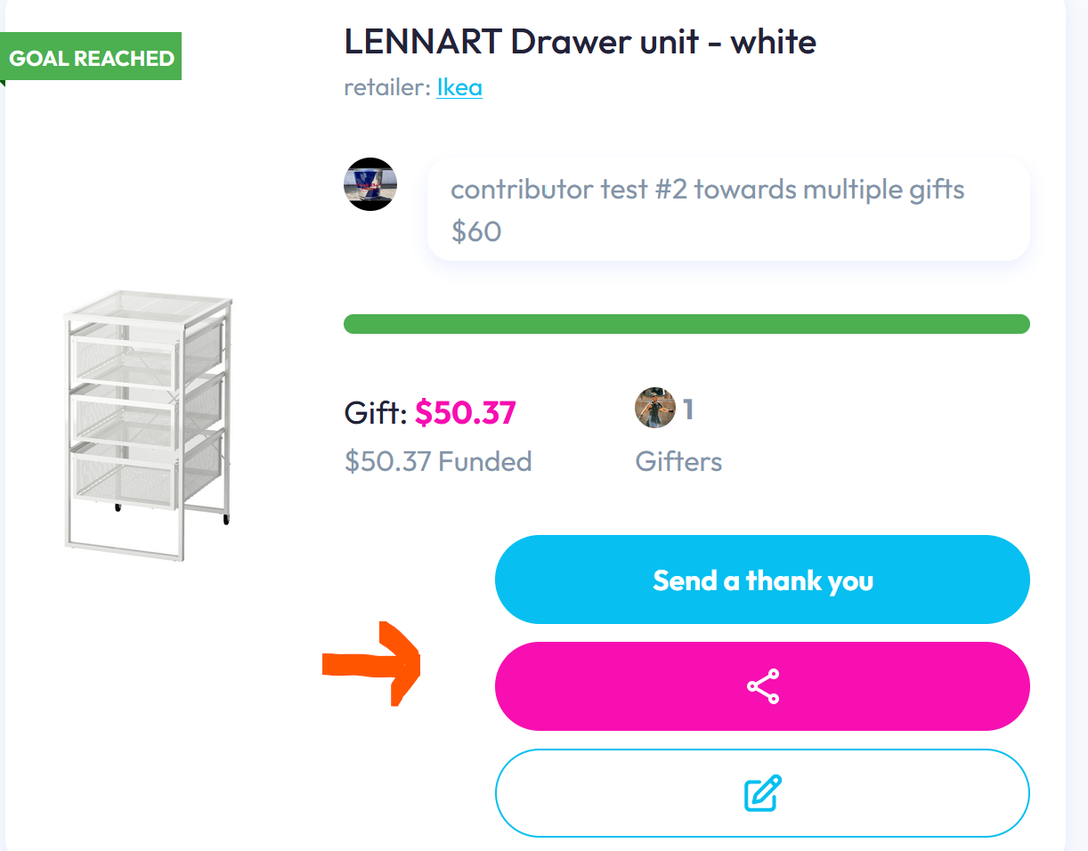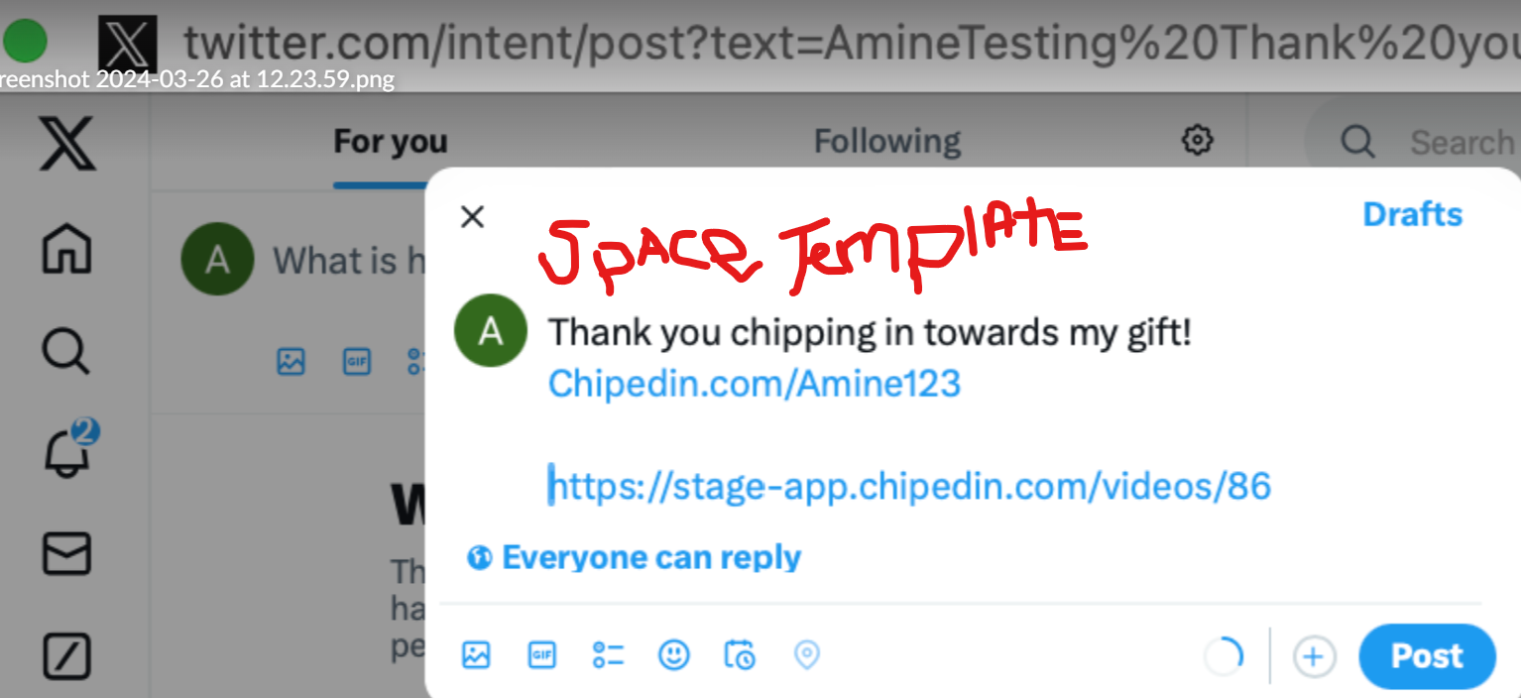
• Email – Change subject line to “Thank you for chipping in towards my gift!”
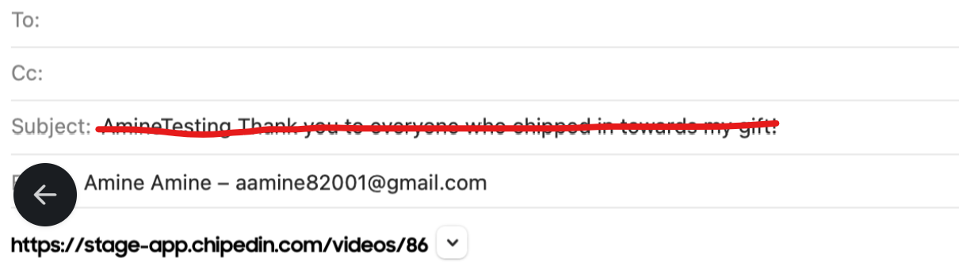

Email
Please use the statement templates given above when user clicks on email icon.

CONTRIBUTOR Share Gift / Wish List
Let’s chip in towards this gift! Chipedin.com/Amine123/Gift (Gift)
Let’s chip in together! Chipedin.com/Amine123 (Wish List, Greeting, Main Profile)
(Share the Individual Picture)
Facebook / X:
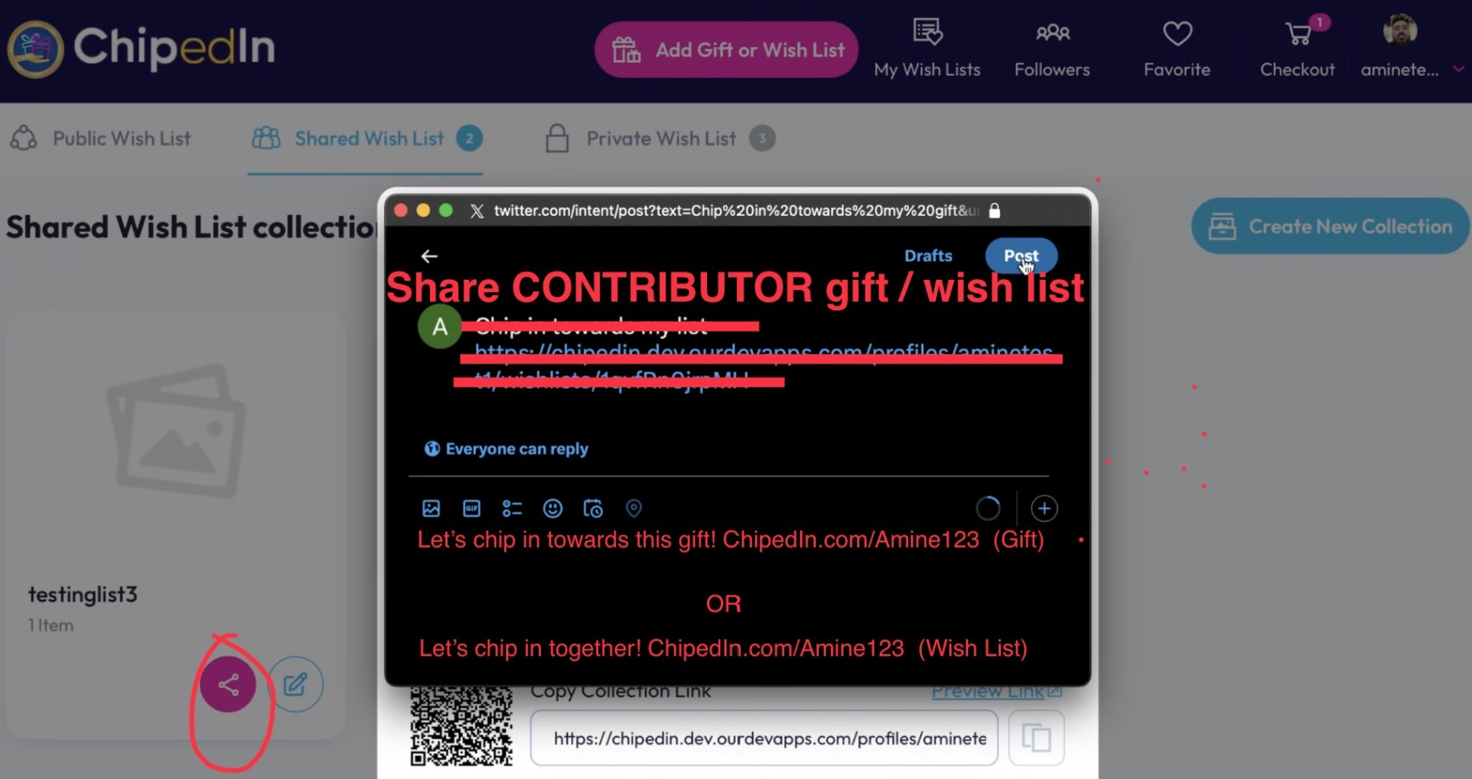

CONTRIBUTOR GOAL REACHED Individual Item
This item was funded! Chipedin.com/Amine123/Gift (Gift)

*Please also check Portrait Pictures/ Videos as it uploads incorrectly (it’s not centered).
